3W Homework. Term 4 Week 7 - This week’s homework is due on Tuesday 25 November
Spelling Words  1.______________________  2.______________________  3.______________________  4.______________________  5.______________________  6.______________________  7.______________________  8.______________________  9.______________________  10._____________________  11._____________________  12.____________________ | 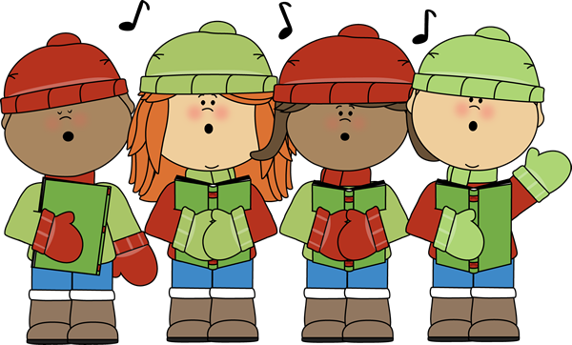  Spelling –  1. Write your words out in syllables. i.e. com.pu.ter  2. Write 5 spelling words into sentences.  3. Have an adult test you on your words.  4. PRACTICE, PRACTICE, PRACTICE  Costumes for Christmas Concert: We are going to run through a full dress rehearsal in week 8 for our Christmas Concert on Thursday 26 November.  Could you please bring a pair of denim pants/shorts/skirts that are of an appropriate length and a plain red/blue/yellow t-shirt to wear. All year 3 students will be needing this attire as it forms part of their costume for the concert. Please make sure you label your items as we would hate to misplace them!  We are also desperate for some mistletoe, holly wreaths, coloured lanterns and a donkey mask – if you could help us out that would be great.  Collection for Lawrence – Thank you class for generously supporting Lawrence and his family.  Next week, we are going to be writing letters to Lawrence. I would like you to think about some things that Lawrence may like to know about you, our class, school or even Australia. In your homework book, write a letter to Lawrence. | Reading – Although we have no readers this week, you still need to keep up your reading…  You could go onto bugclub, read a favourite book from home or visit your local library. Remember to look for a GOOD FIT BOOK.

